**Question:**

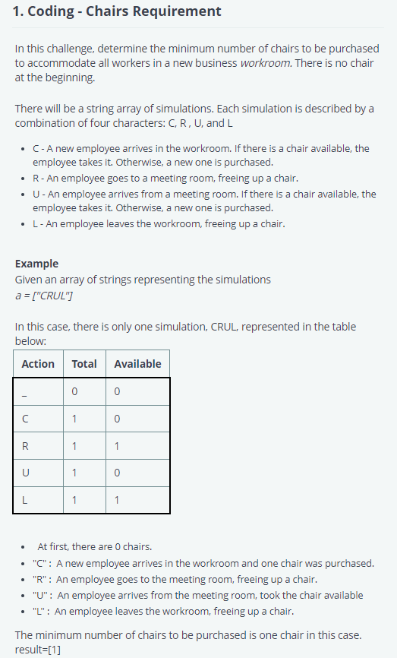

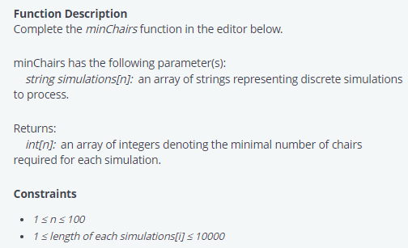

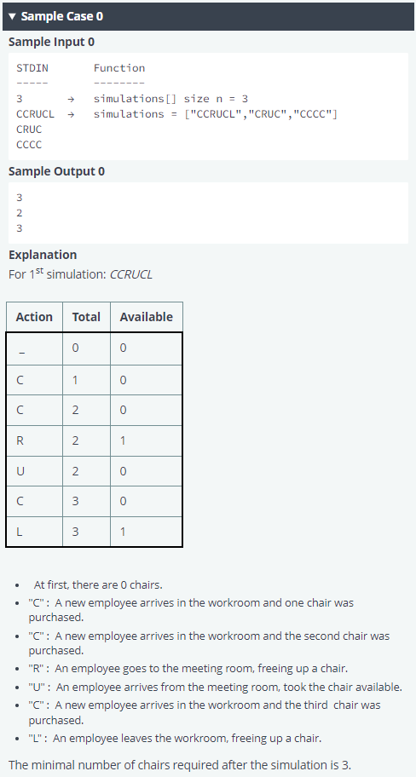

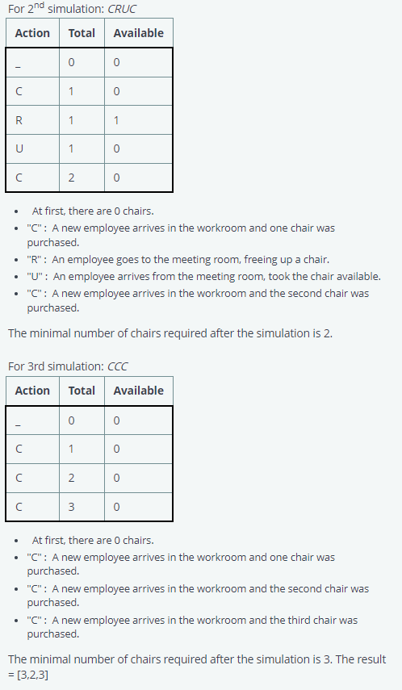

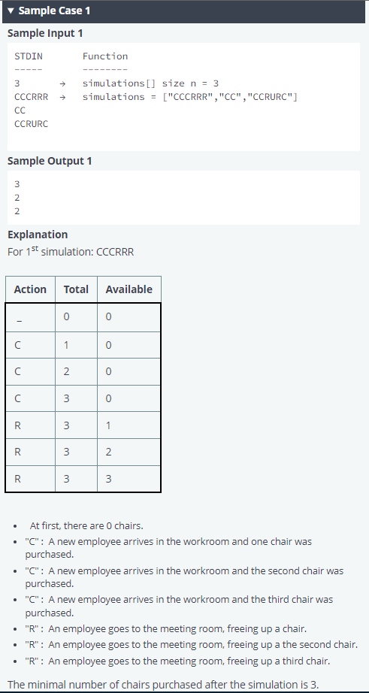

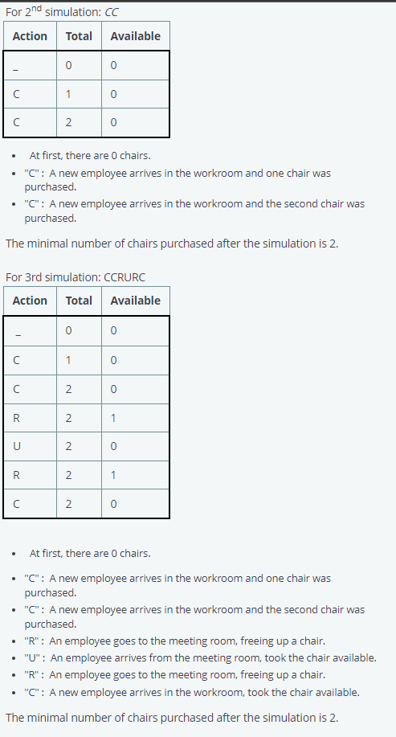

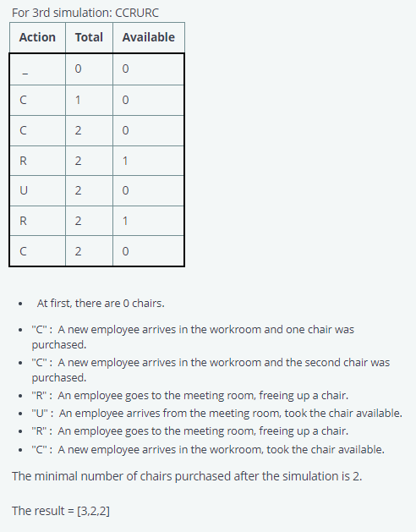

**Solution:**

# Complete the 'minChairs' function below.

# The function is expected to return an INTEGER_ARRAY.

# The function accepts STRING_ARRAY simulations as parameter.

* *Here C and U means ‘Cum’ and ‘R’ and ‘L’ means ‘Go’.*
* *When ‘Cum’ happens:*
  + *If available chair not present (a = 0), a chair is purchased (t = t + 1).*
  + *Elif available chair is present, then user sits on that chair (a = a - 1).*
* *When ‘Go’ happens, available chair increases (a = a + 1).*

def minChairs(strings):

# Write your code here

chairs = []

for i in strings:

t = 0

a = 0

for j in i:

if j == 'C' or j == 'U':

if a == 0:

t=t+1

else:

a=a-1

elif j == 'R' or j == 'L':

a=a+1

#print(t)

chairs.append(t)

return(chairs)

if __name__ == '__main__':

fptr = open(os.environ['OUTPUT_PATH'], 'w')

simulations_count = int(input().strip())

simulations = []

for _ in range(simulations_count):

simulations_item = input()

simulations.append(simulations_item)

result = minChairs(simulations)

fptr.write('\n'.join(map(str, result)))

fptr.write('\n')

fptr.close()